Link Solax EVC to the Alexa App
Author: Daniel
Reviewer: Eason
EVC
Issue introduction
Link Solax Account to the Alexa App
Operation guidance
Step1: Register an Alexa account and log in to the app.
Step2: Go to the “More” menu, select “Skills & Games”, then search for and select “Solax Power” (note the space in the middle). After that, click 'Launch' to download the skill."
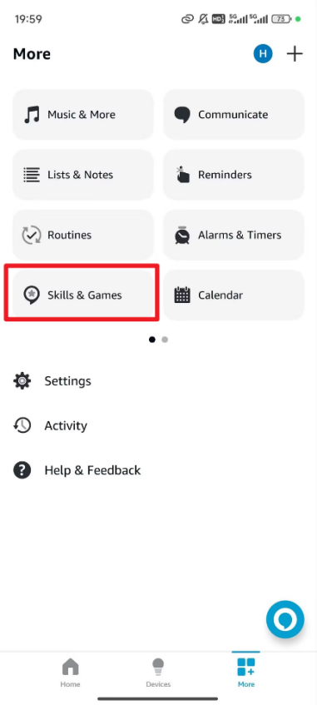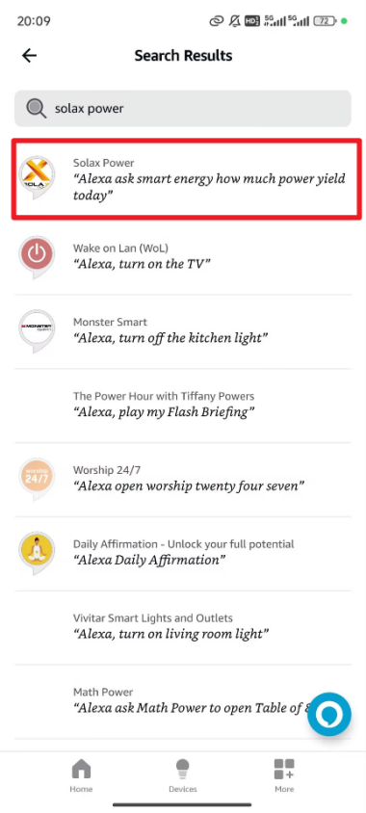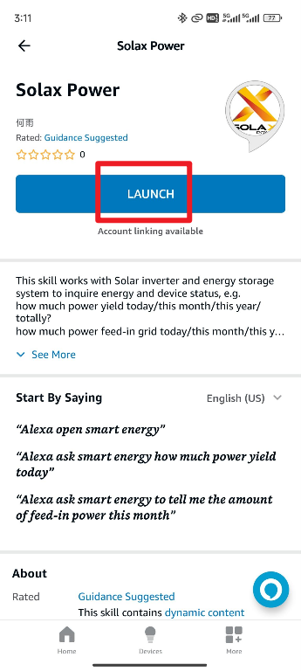
Step3: Click “SETTINGS” to enter the settings interface, then click “Link Account” to match your account. After that, Go to the Solax Global website: https://www.eu.solaxcloud.com/user-center/ and log in with your end user account.
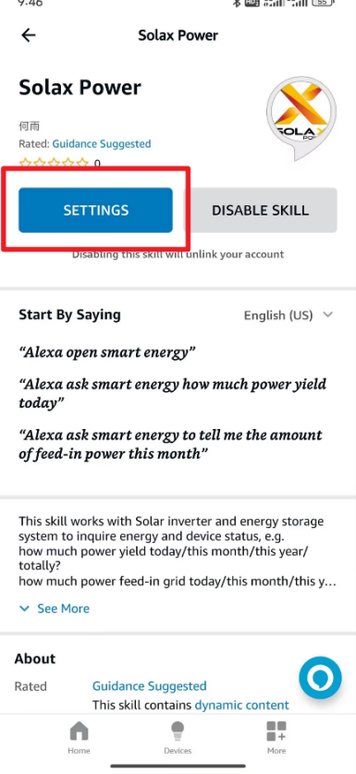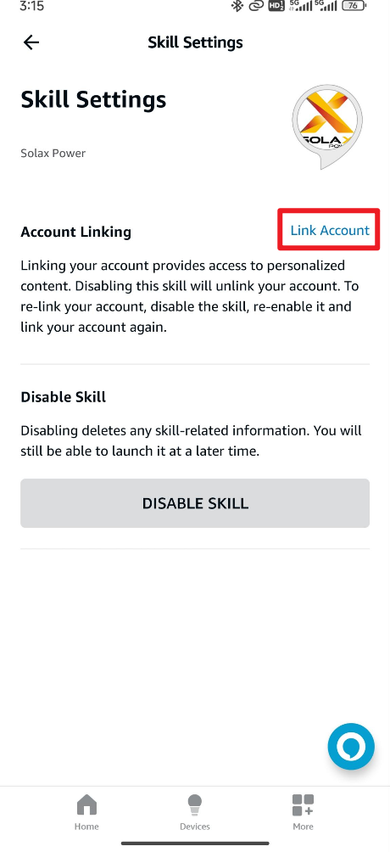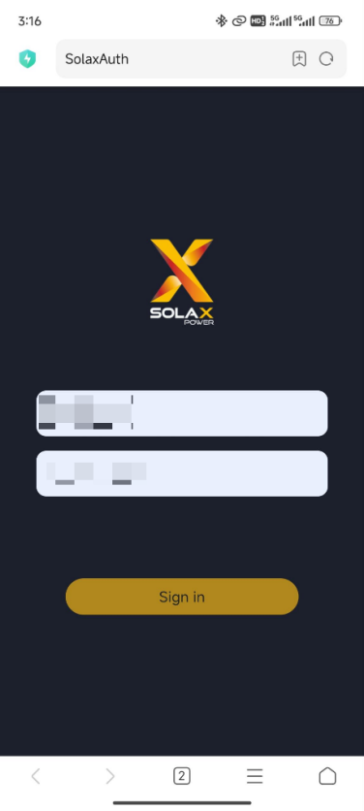
Step3: After logging in successfully, return to the Solax Power skills page and check if the account is linked. If “Linked” is displayed, the account has been successfully bound.
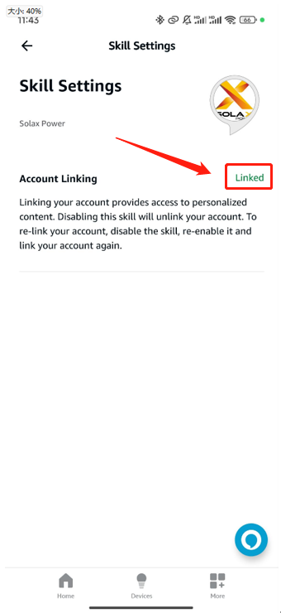
Voice Control Manual
Start the assistant | alexa open smart energy
Check the EVC status | my charger current status
Check the EVC work mode | my charger current mode
Check the current charging amount of the EVC | my charger about the amount of electricity charged this time
Check the current charging power of the EVC | my charger the charging power this time
Switch the EVC work mode to Green | my charger set to Green mode
Switch the EVC work mode to Eco | my charger set to economy mode
Switch the EVC work mode to Stop | my charger set to Stop mode
Switch the EVC work mode to Fast | my charger set to Fast mode
Please note
- If the settings save fails, please check your mobile network, ensure a stable connection, log out of your account, and then log back in. Follow the steps above to make the changes.

